Abstract Title(18pt Calibri Using Capitalization Only on First Letter of Major Words and Centered, 1line spacing)

Author’s Name1^{1*}, Author’s Name2², Author’s Name3¹ (11 pt Calibri and Centered)
¹Affiliation A, Korea
²Affiliation B, Korea (10pt Italic, Calibri and Centered, 1line spacing)

Abstract Submission Guidelines
Abstracts must be written clearly in English or Korean and submitted prior to Oct. 13 (Mon.) 2025. Authors may further edit and modify submitted abstracts until the submission deadline.
Title— Use a concise title that reflects the content of the abstract. The complete title should have the first letter capitalized.
Authors— Full names, including surnames, for each author must be provided. Do not include degrees or titles. The presenting author’s name should be placed at the very front and marked with an asterisk (*) following the name. The corresponding author’s name should also include a cross symbol (†) next to the name.
Affiliations— Affiliation should include the institution and department.
Contents— Abstracts should be typed in Calibri 10-point font, on A4-sized paper (21.0 by 29.7 cm) in vertical format. The content should be one page or within two pages. Submitted abstracts will be reproduced exactly as submitted. Images—If an abstract includes images, they should be placed at the middle of the abstract or at the end of the abstract. Specify the image resolution in 300 dpi.

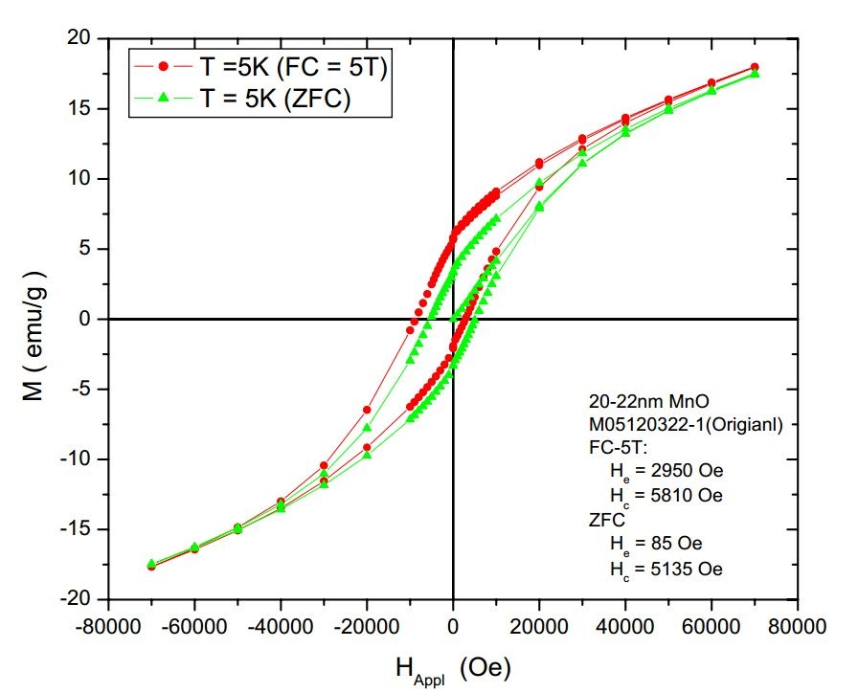
Fig. 1. A sample line graph
(1line spacing / image size: 300 dpi)

